**5006 lab 1**

Lab 1

This is task one of lab task 1, i saved my index.js file in a folder on my desktop and insured it knew the directory of my file. Then ran the code using “node index” to display the desired output.

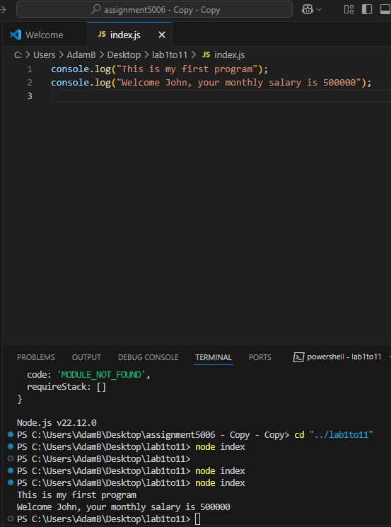

In task 2, I entered the provided code into my index.js file which outputted the sum of 5 and 3 as intended

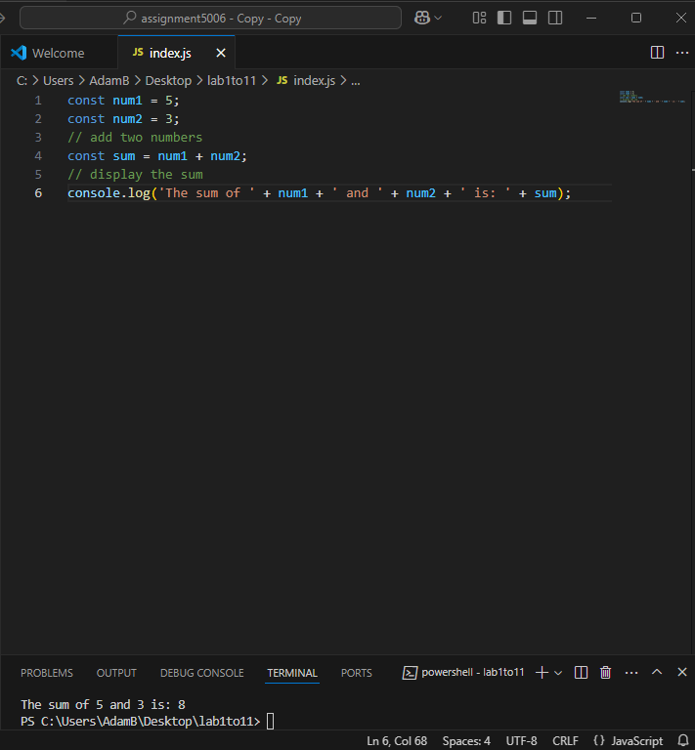

The third task, I entered the provided code into my Index.js file which compiled the correct output as “enter a number” was the first line of text to show, followed by the next text depending on the number entered.

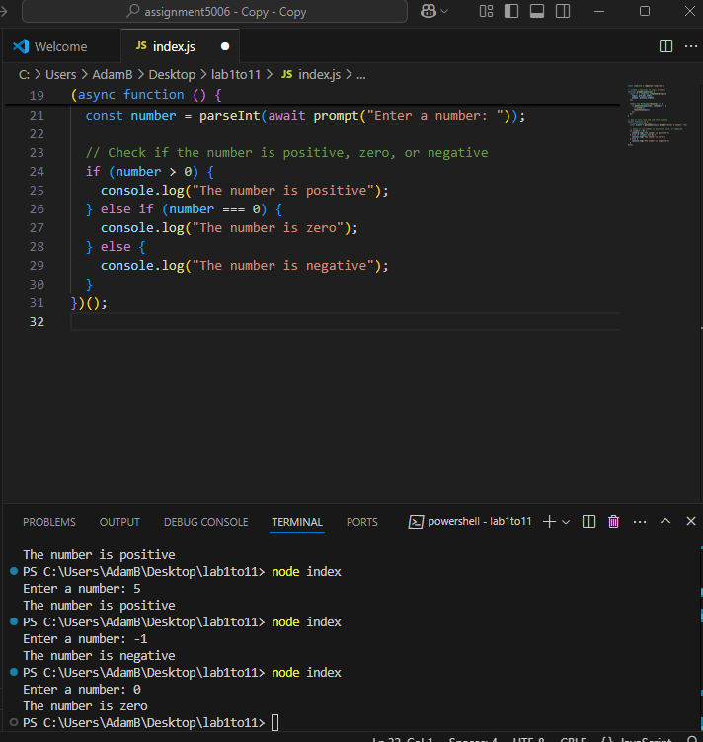

The last task is to create a program that can perform addition, subtraction, multiplication and division of two or more numbers.

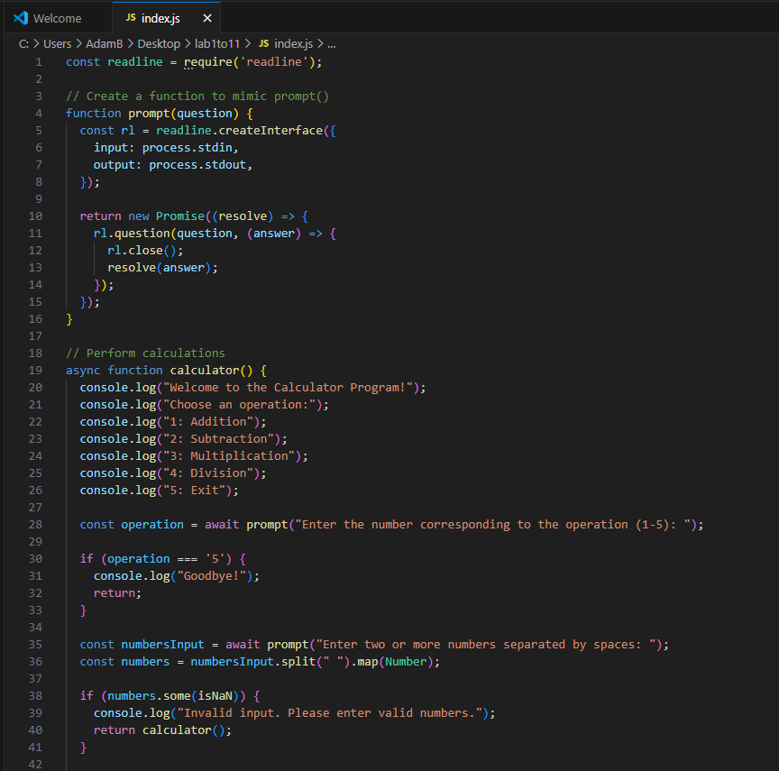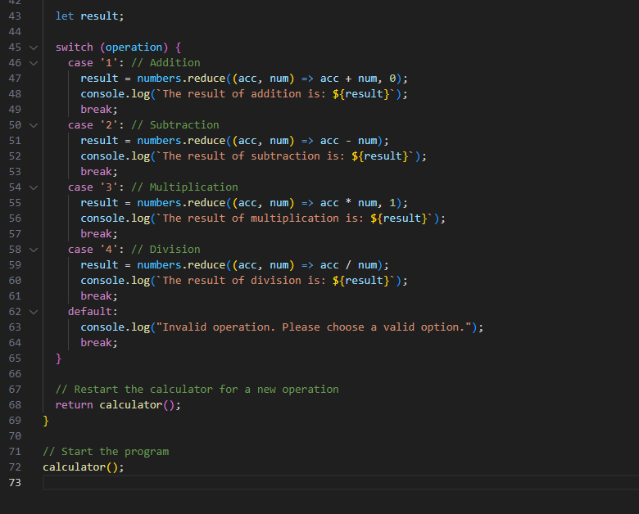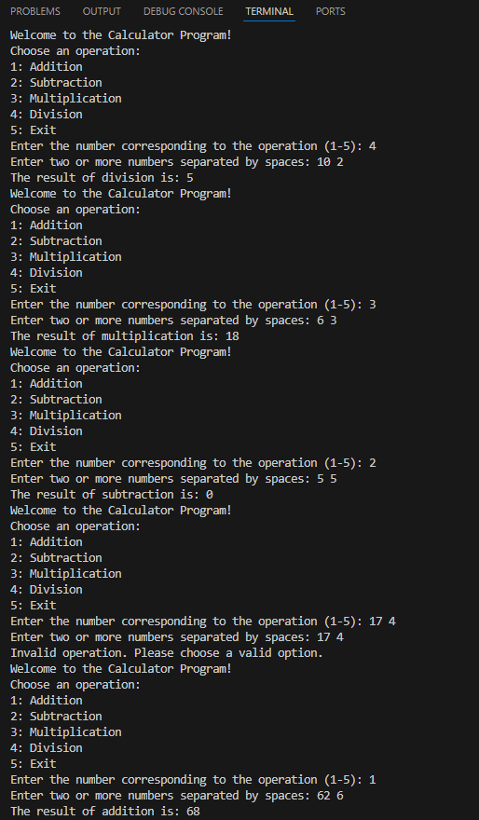

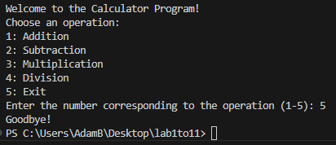

This program uses a switch statement to decide which calculation to perform based on the user's choice.

The break keyword is used in each case of the switch to stop further execution after performing the chosen operation.

The list of operations (addition, subtraction, multiplication, and division) is displayed to the user at the start, making it easy to select what to do.

The return statement is used to exit the current function or restart the calculator for another calculation.

All my programs use the readline module to handle user input and display the output using a general prompt like “node index” as opposed to a specific prompt which changes with the code.